Baker Buddy Picnic
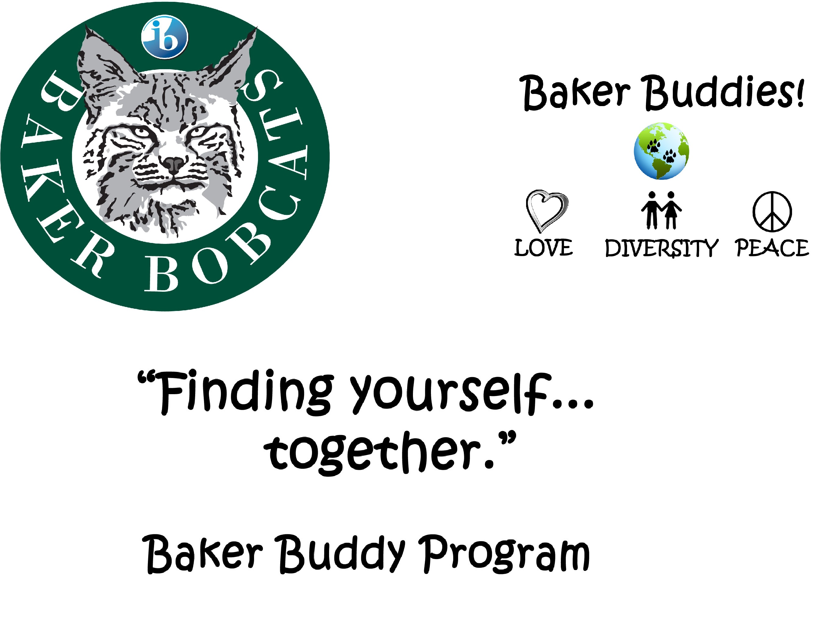
Thursday, June 4
During 4th Hour

Thursday, June 4th – during 4th Hour
Please report to the main office after 3rd hour.

Please sign below to indicate that you give permission for your child to participate in this activity.
They will miss their 4th hour class.
Students are responsible to turn in any homework prior to missing class.
Students are also expected to complete any work they miss.
Return to Mrs. Chlebek in the main office by Tuesday, June 2nd.
Permission slips will NOT be accepted after June 2nd.

Child’s Name ______________________________________________________________________ (Please Print)
Parent Signature ___________________________________________________________________

4th Hour Teacher Signature _________________________________________________________

